

# Microsoft Surface Go 2 4G

## Type of device: Tablet

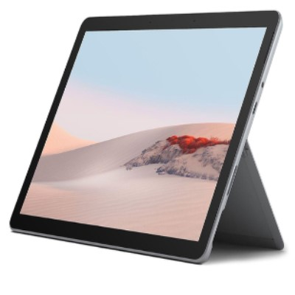

Actual Display Size : 10.5 inches

Operating System : Microsoft

Network Capability : 3G,4G

Year of Release : 2020

Average Price : $889 as of 28 09 2021

Internet Access : Wi-Fi Only

## Accessibility Features:

### Cognitive

* Additional Instructions
* Copy and Paste
* Flicker Free Display
* GPS
* Photo Telephone List
* Screen Timeout Disabled
* Simple Instructions
* Simple Reminders
* Simplify Display

Voice Notes

### Hearing Impairment and Deaf

* Allows for sign language communication
* Bluetooth or Wi-Fi
* Closed Captioning
* Front Facing Camera
* Video Communications - Two-way

Visual Alerts - Incoming Calls

### Vision

* Accessibility APIs supported
* Battery Alert - Audible
* Bluetooth or Wi-Fi
* Braille Display Support
* Brightness Adjustable
* Dictation / Speech-to-Text
* High Contrast Mode
* Personalised Shortcuts
* Power Cue
* Screen Magnifier
* Screen Reader
* Text Size Adjustable
* Voice Control /Personal Assistant

Voiced Menus

### Speech

* Allows for sign language communication
* Bluetooth or Wi-Fi
* Messaging Options - Email

Predictive Text

### Physical

* Bluetooth or Wi-Fi
* Dictation / Speech-to-Text
* Flat Back for Table Top Operation
* Gesture Based Navigation
* Headset - plug connected
* Predictive Text
* Reduced hand movement option
* Speaker-phone option
* Stylus or Prosthetic Device support
* Switch control option
* Visible Focus Indicators
* Voice Control / Personal Assistant
* Voice Recognition for Accessing Features

Voice Recognition for Dialling

## How and where to get it from?

You can buy this tablet from [Kogan](https://www.kogan.com/au/shop/category/tablets/?q=Microsoft+Surface+Go+2&page=1), [The Good Guys](https://www.thegoodguys.com.au/SearchDisplay?categoryId=&storeId=900&catalogId=30000&langId=-1&sType=SimpleSearch&resultCatEntryType=2&showResultsPage=true&searchSource=Q&pageView=&beginIndex=0&orderBy=0&pageSize=60&searchTerm=Microsoft+Surface+Go+2), [Dick Smith](https://www.dicksmith.com.au/da/shop/category/tablets/?q=Microsoft+Surface+Go+2&page=1), [Microsoft](https://www.microsoft.com/en-au/d/surface-go-2/8pt3s2vjmdr6?cid=msft_web_collection&activetab=pivot%3aoverviewtab), and other retailers.

## More information is available on:

[Microsoft Surface Go 2 Web Page](https://www.microsoft.com/en-au/d/surface-go-2/8pt3s2vjmdr6?activetab=pivot%3aoverviewtab)

[Microsoft Surface Go 2 Features Web Page](https://support.microsoft.com/en-us/surface/surface-go-2-features-0fc6a657-2851-484f-6f82-bd3c589ed92c)

[Microsoft Surface Go 2 Support Web Page](https://support.microsoft.com/en-gb/surface-go?ui=en-US&rs=en-GB&ad=GB)